

Game Design Document

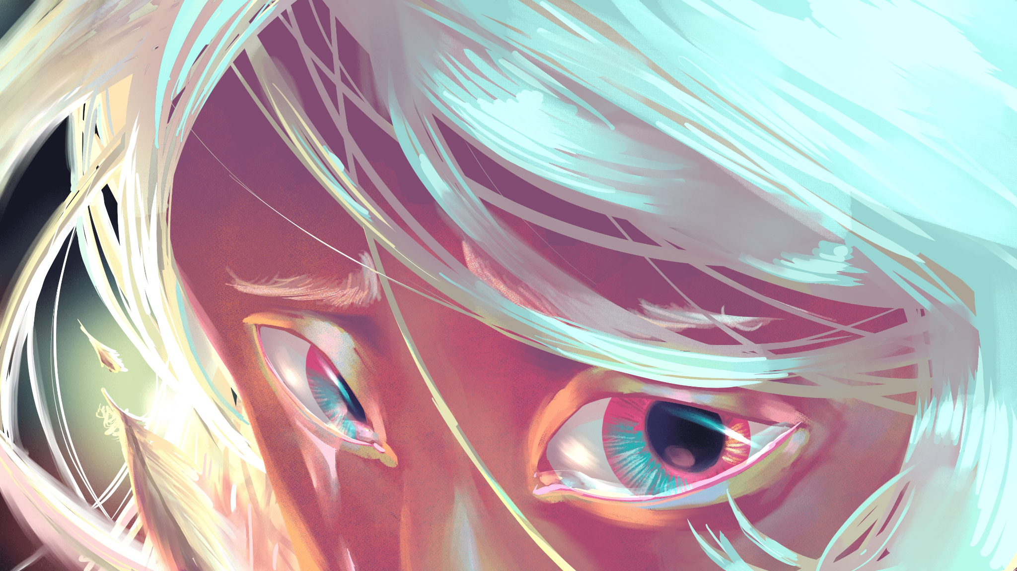

WRITTEN BY:

Game Director: Edward Cheng
Narrative Director: Cole Barrios
Lead Designer: Dylon Shiao
Game Designer: Sid Wang

Table of Contents

Overview 4
Game Description 4
Genre 4
Platform 4
Target Audience 4
Experience Goal 4
Story 4
Core Gameplay Loops 5
Macro Gameplay Loop 5
Combat Gameplay Loop: 6
Design Pillars 7
1. Environmental-Based Combat 7
2. Fluid Controls 7
3. Infinite Replay Potential 7
4. Layered Complexity 7
5. Narrative and Design Cohesion 7
Game Design 7
Beira 7
Dash 8
Camera 8
Controls 8
Keyboard: 8
Controller: 9
Locations 9
Sanctuary (Hub level) 9
The Faewild 10
Room Navigation: 12
User Interface 12
Health 12
Inventory Menu 13
Environment 13
Enemies 14
Items 15
Status Effects 16
Progression 16
Echoes 16
Favors 17
Art and Sound 17
Glossary of terms 18

Overview

Game Description
- Echoes is an isometric action roguelite that revolves around dash-based combat.
- Players step into the shoes of Beira, an amnesiac fae queen, embarking on a quest to regain her lost memories by exploring her former kingdom.
- What sets Echoes apart from other dungeon crawlers? There is no attack button!
- Instead, the player will have to eliminate enemies by dashing between faerie circles, and luring enemies into hazards.
- Each level is procedurally generated, making every run unique.

Genre
- Action, Isometric, Roguelite

Platform
- PC, Console

Target Audience
- Gamers Ages 10+ who enjoy challenging games,
- Fans of 2D roguelikes, dungeon-crawlers, and platformers.

Experience Goal
- Provide players with a sense of exhilaration and empowerment
- Challenge players with tense but rewarding gameplay
- Keep players coming back for “one more run” every time they die
- Provide a high skill ceiling for hardcore players, while maintaining accessibility for more casual gamers.

Story
- Beira, the faerie queen of Eile is overthrown in a coup masterminded by Rot, a scheming High Court Fae
- Rot strips Beira of her memories and banishes her to wander the Faewild.
- Beira must recover her lost memories to regain her powers and learn what happened to the Faewild.
- Beira must fight her way past Rot’s minions through the now ruined Faewild to reclaim her throne.
- Lore is told mostly through cookie crumb narrative–vo narration, Beira VO, vo callouts, environments, and item descriptions.
- Upon reaching Rot, Beira realizes that he has been draining the Faewild of its power to keep himself alive
- Whenever she dies, Beira respawns in the hub (sanctuary)

Core Gameplay Loops

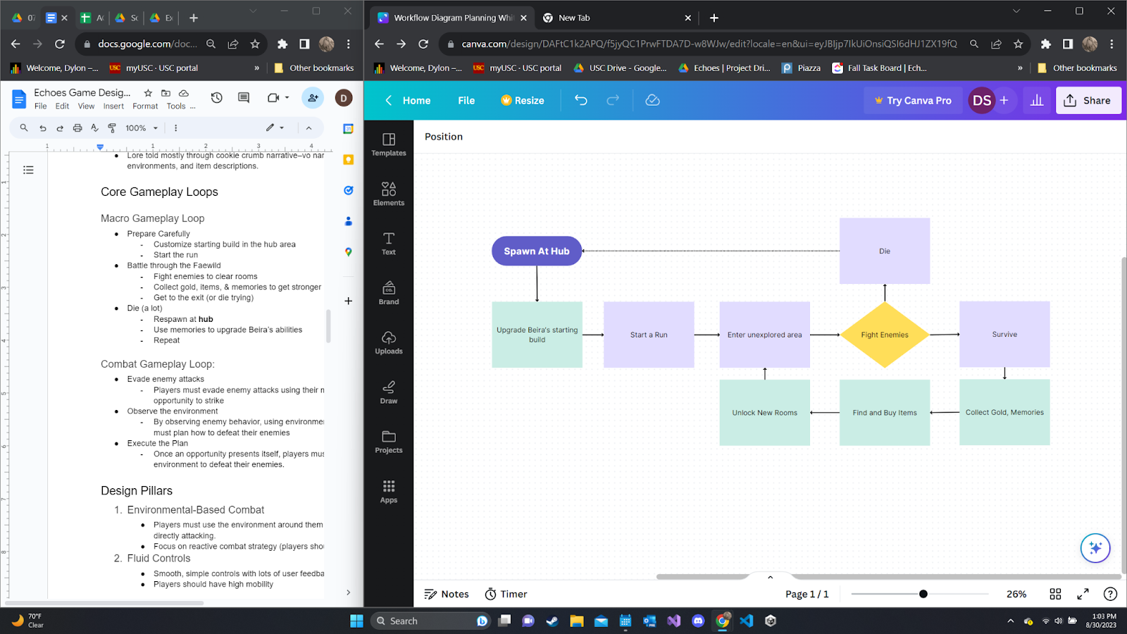
Macro Gameplay Loop
- Prepare Carefully
  - Customize starting build in the hub area
  - Start the run
- Battle through the faewild
  - Fight enemies to clear rooms
  - Collect items to get stronger
  - Defeat the final boss (or die trying)
- Die (a lot)
  - Respawn at the hub
- Repeat
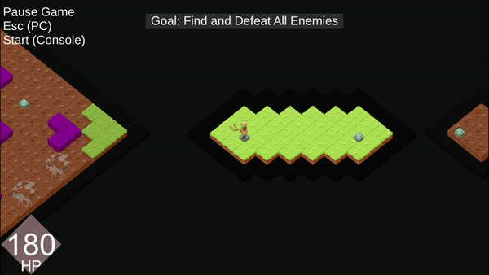

Combat Gameplay Loop:
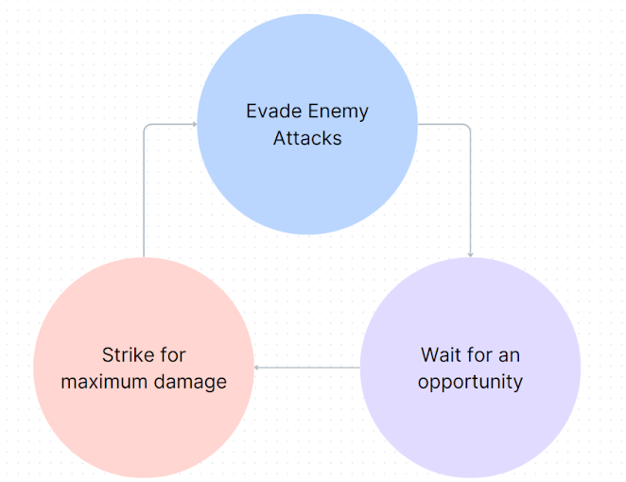
- Evade enemy attacks
  - Players must evade enemy attacks using their mobility and wait for an opportunity to strike
- Wait for an opportunity
  - By observing enemy attack patterns, using environmental hazards, and terrain players must plan how to defeat their enemies
- Strike
  - Once an opportunity presents itself, players must use their dash and environmental tools to swiftly defeat their enemies.

Design Pillars

Environmental-Based Combat
  - Players must use the environment around them to damage enemies, rather than directly attacking.
  - Focus on reactive combat strategy (players should adapt to the situation)

Fluid Controls
  - Smooth, simple controls with lots of user feedback
  - Players should have high mobility

Infinite Replay Potential
  - Each run should be a unique experience
- Items, environments, abilities should meaningfully change gameplay & support many strategies
  - Encourage players to keep playing after a death

Layered Complexity
  - Designs start simple, but combine to create complex interactions

Narrative and Design Cohesion
  - Design and narrative should flow together

Game Design

Beira
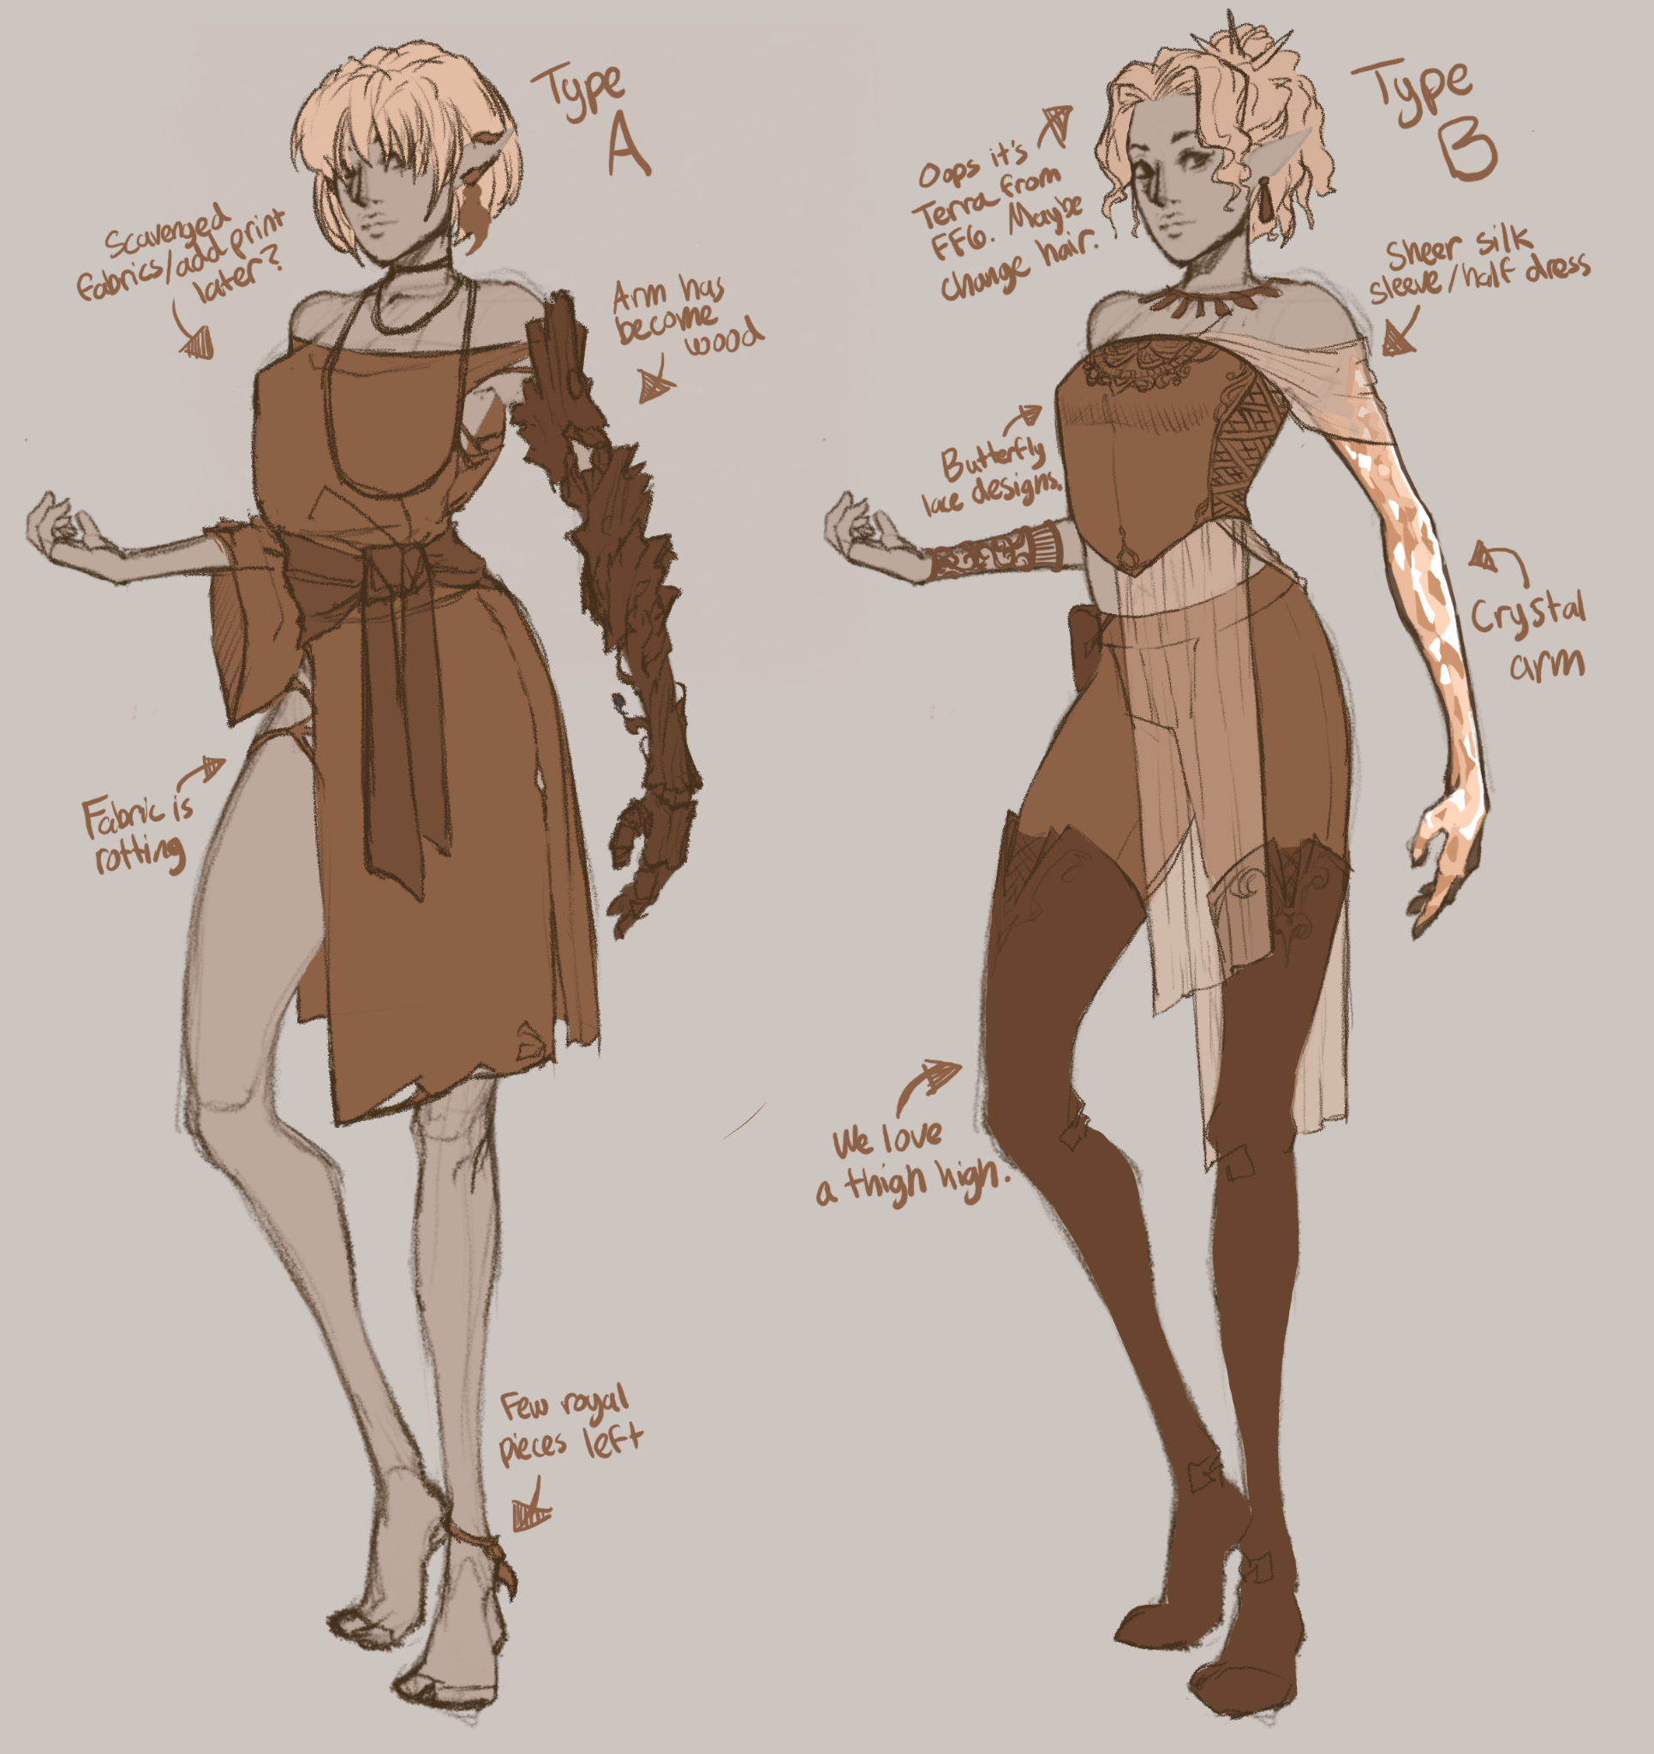
Players play as Beira, the former Faerie queen of the Otherworld, now stripped of her powers and memories. As she collects items, she will gradually get stronger and unlock more abilities. Beira’s basic kit includes movement and a dash.

Dash
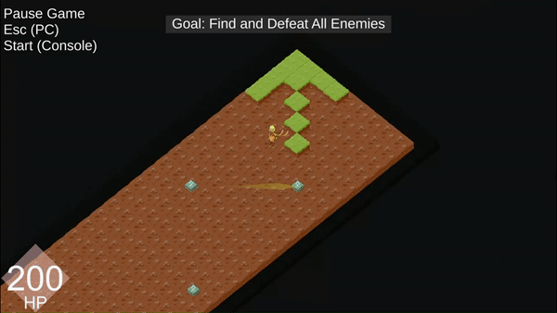

Beira quickly dashes to target faerie circles, dealing damage to all enemies she passes through.
- By default the target faerie circle is the closest faerie circle in the direction Beira is currently facing.
- Using the aim feature will shift the dash destination to the closest faerie circle in the direction of the aim input

Camera
- Echoes uses an isometric top-down perspective, with the camera centered on Beira.

Controls

Keyboard:

Command | Keybind
Movement | WASD
Aim | Mouse
Dash | Space || LMB
Interact | E
Pause | Escape
Inventory | Tab
Confirm | LMB || Space
Cancel | Escape
Menu Navigation | Mouse || WASD

Controller:

(Made with padcrafter)

Controls (V2)
Command | Controller Binding
Dash | A
Interact | B
Open Inventory | View (left)
Pause | Menu (pause)
Movement | Left Joystick
Menu Navigation | D-Pad & Left Joystick
Confirm | A
Cancel | B

Locations

Sanctuary (Hub level)
Whenever they die, players respawn in Sanctuary, the hub level, there they can do the following:
- Customize their starting abilities at the Mural of Epoch
- Test their abilities in a small training area
- Enter the Faewild

The Faewild
Once they enter the Faewild, players are transported to a procedurally generated level composed of various floating islands and rooms. Players navigate between rooms by dashing to faerie circles with the dash ability.

In the future, a full run would composed of three Faewild regions. However, our game will only include the Darkwood Region. Each region has a distinct atmosphere and theme:

- The Darkwood: a gloomy and ominous forest at the edge of the Faewild
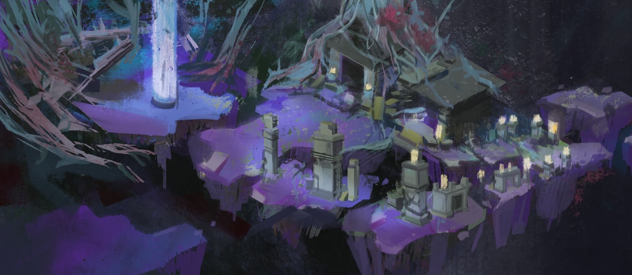

- Ruins: a once great city that has fallen into decay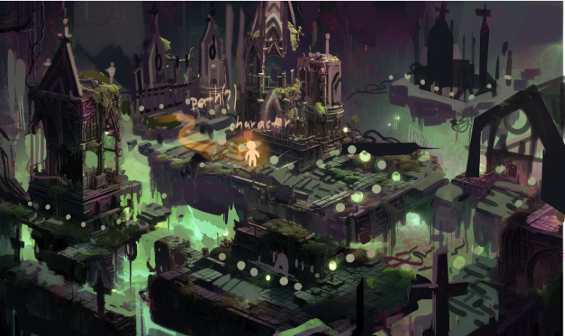
- Sacred Forest: the capital of the Faewild and former seat of the Eile High Court, now the stronghold of Rot and his minions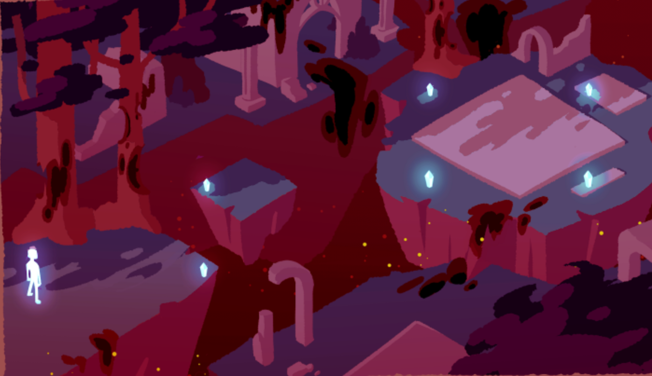

Each region will get progressively harder. Regions are procedurally generated and contains the following rooms:

Room | Description
Spawn Room | A safe room where the player initially starts in
Combat Room | Contains varying amounts of enemies, faerie circles, loot, and environmental hazards.  - Upon entering a combat room, a wave of enemies spawn  - After defeating a wave of enemies, additional waves of enemies can spawn  - Enemy waves are semi-randomized, with rooms in later regions spawning stronger enemies  - During combat, exits to neighboring rooms are blocked by until all enemies are defeated.  - Upon clearing a room, the path(s) to neighboring rooms are unlocked.  - Combat rooms may spawn have multiple waves of enemies
Echoes Room | Contains a shrine with a special item  - Upon interacting with the item, the player will see a brief narrative flashback that reveals clues about Beiras past
Shop Room | Contains a vendor that lets players buy items and health potions for favors dropped by defeated enemies.  - At least one shop is guaranteed to spawn every level.
Boss Room | Contains the boss fight with Rot

The faewild will be procedurally generated, but follow the general pattern below:
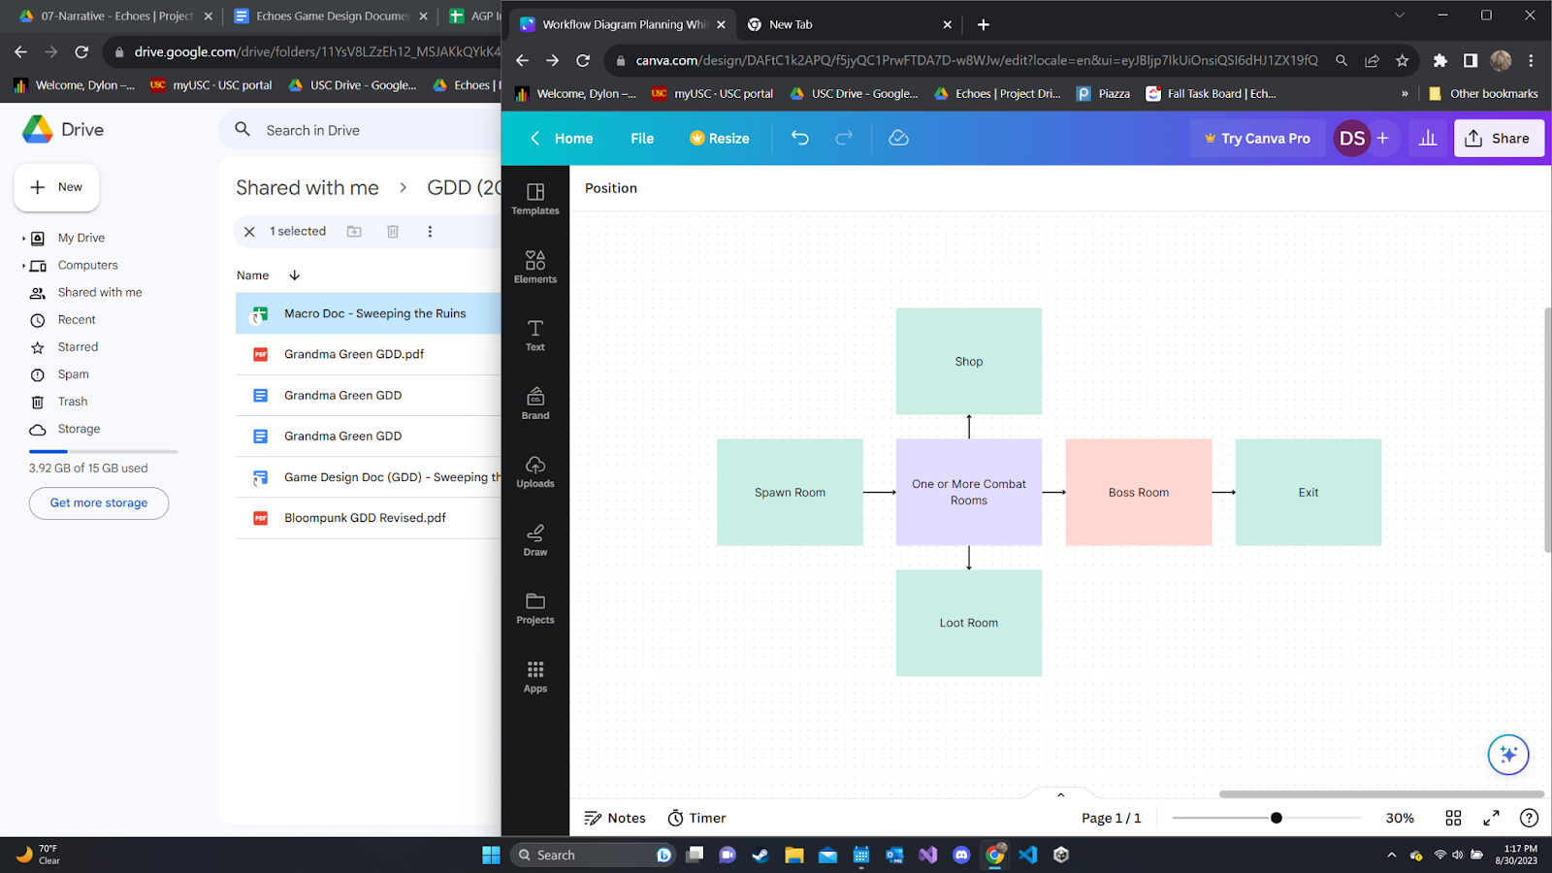

Room Navigation:
- Fog of war blocks player vision, preventing them from dashing to faerie rings they cannot see
- After beating a room, the player can choose from up to 3 different room types to enter
- Leaving a room causes it to disappear (players cannot backtrack)

User Interface

Health
- Beira’s current health will be displayed on a UI panel in the top left corner of the screen:

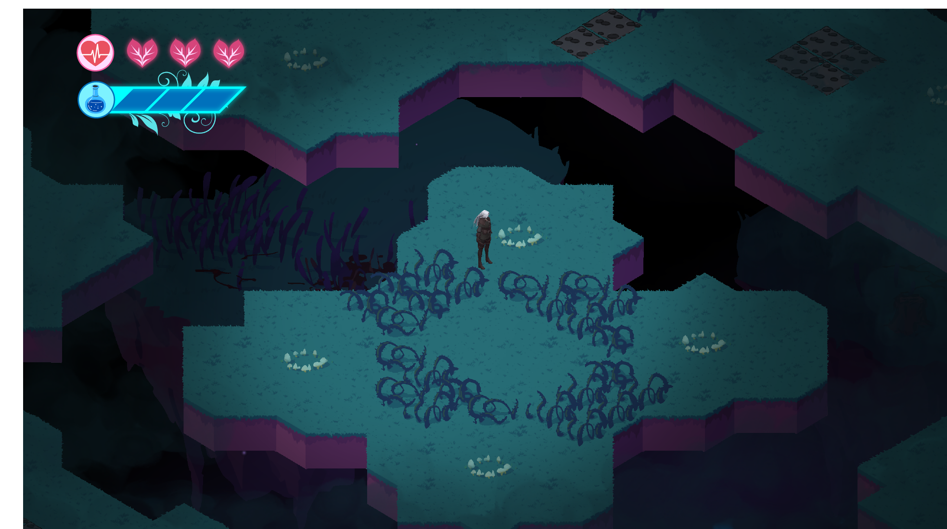
- Hearts represent the number of hitpoints she has left
  - As Beira gains more HP, the length of the HP bar will extend

Inventory Menu
A menu accessible during the game that displays contextual information. The inventory can be opened using the open inventory hotkey. It contains the following tabs:

Inventory Tab
- Shows all currently equipped items and their effects
Journal
- Lists all items and enemies the player has encountered across all their runs
- Locked items show up as a “???” entry
- Selecting an item displays its description, stats, and abilities

Environment
faewild rooms can contain a variety of environmental objects. These objects appear semi-randomly in rooms of the faewild. There are several different types:
- Hazards: Damage entities (players and enemies)
- Obstacles: impede movement of entities
- Interactables: Can be interacted with for various effects

Object: (Type) | Description
Spike Trap (Hazard) | Thrusts damaging spikes up from the ground. While active, damages characters standing on them.  - Automated Spike Trap: periodically activate and de-activate every few seconds
Wall (Obstacle) | Prevents entities from moving through
High Wall | Prevents entities from moving or dashing through
Faerie Circle (interactable) | A small circle of stones where magical ley lines converge. Beira can dash to these from far away.  There are several variants of Faerie circles:  - Cooldown Circles: get disabled for a short period after dashing to them  - Refresh Circles: refresh your dash when you dash to them
Shrine (interactable) | Upon interaction, presents players with a choice of items they can take. Locked while enemies are present.
Shopkeeper (interactable) | A friendly NPC found in the faewild who buys items for favors.

Enemies
Beira will encounter various types of enemies during their journey:

Name | Description
Minion | A fast but very weak melee enemy. Attempts to rush the player and surprise them with their quick movement.
Soldier | Basic melee enemy. Has moderate hp, but is relatively slow and easy to kite.
Archer | Shoots ranged attacks at the player from a distance
Mage | Shoots telegraphed ranged attacks that can be easily dodged. Has a lengthy wind-up animation.
Tank | Beefy melee enemy. Slowly walks towards the player. Has large telegraphed mid-ranged slam aoe attacks that do a lot of damage.

Items
- Items are power-ups that make Beira stronger when equipped. Items can give Beira new abilities, or enhance existing abilities.
- Items can be found in shrines throughout the faewild and purchased from shops using favors.
  - Upon opening a shrine, a player will be presented with a choice of 1-3 rewards, from which they can pick one to receive.
  - Rewards can include items, favors, and health potions
  - One of the rewards is guaranteed to be an item
- Items have varying levels of rarity depending on their power, which determines how likely they are to show up in shrines.
- Items can be bought at shops for favors
  - Item prices are based on the item rarity
- Players can read about items they’ve discovered previously in Beira’s journal.
- Some items are not eligible to spawn in shrines until the player has completed certain progression milestones (see progression)
- Full item list: Macro Design Proposals
- Items can have some of the following tags:

Tag | Description
Base | The basic items that given to players at the start of the tutorial (available by default)
Undiscovered | Items that the player has not equipped before during their playthrough.  - The items description and stats are unavailable in the journal (marked as ???) until discovered.  - Equipping the item discovers it.
Discovered | Items that the player has equipped at least once before during their playthrough.  - Their description and stats are available in the journal.
Starting Items | Items that can be picked as part of a starting loadout (must be unlocked)
Echoes | Items that when unlocked for the first time, trigger narrative moments: 3 to 5 seconds of a still painting showcasing the item in a setting important to Beira’s identity and story progression, followed by narration or noises typical to that setting.

Status Effects
Some items, abilities, and hazards can inflict various status effects on entities:

Effect | Description
Fire | Burns afflicted entities, dealing damage over time.  - Lasts ~3 seconds  - Visuals: afflicted characters emit flames
Frostbite | Slows afflicted entities by 10%. Stacks up to 10 times,  - Upon reaching 10 stacks, the character becomes Frozen.  - Each stack lasts ~5 seconds before wearing off.  - Visuals: afflicted characters are tinted blue, and emit snow particles
Frozen | Immobilizes afflicted characters.  - If damaged before the duration ends the afflicted character takes bonus damage and the effect ends.  - Lasts ~10 seconds.  - Visuals: afflicted characters are frozen in a block of ice
Stunned | Immobilizes afflicted entities.  - Lasts ~2-3 seconds.  - Visuals: afflicted characters have stars spinning around their head
Knockback | Forcibly displaces a character. During this period, all other movement is disabled. If a character is knocked into a wall, they are stunned. If a character is knocked into the void, they will fall and die.

Progression
Progression in Echoes is determined primarily by favors, tears of epoch, and the Journal.

Echoes
Echoes’ and items are the primary form of meta-progression
- Upon equipping an item for the first time, the items entry in the journal will appear, and the item will be unlocked as a starting item in future runs (if applicable)
- Echoes are special items that can be found in shrine rooms.
  - Upon picking them up, they will trigger a short narrative flashback that reveals Beras past

Favors
Favors are the in-run currency used during faewild runs to purchase items at shops during the run.
- favors is collected from shrine rewards and upon killing enemies
- favors is lost upon death

Art and Sound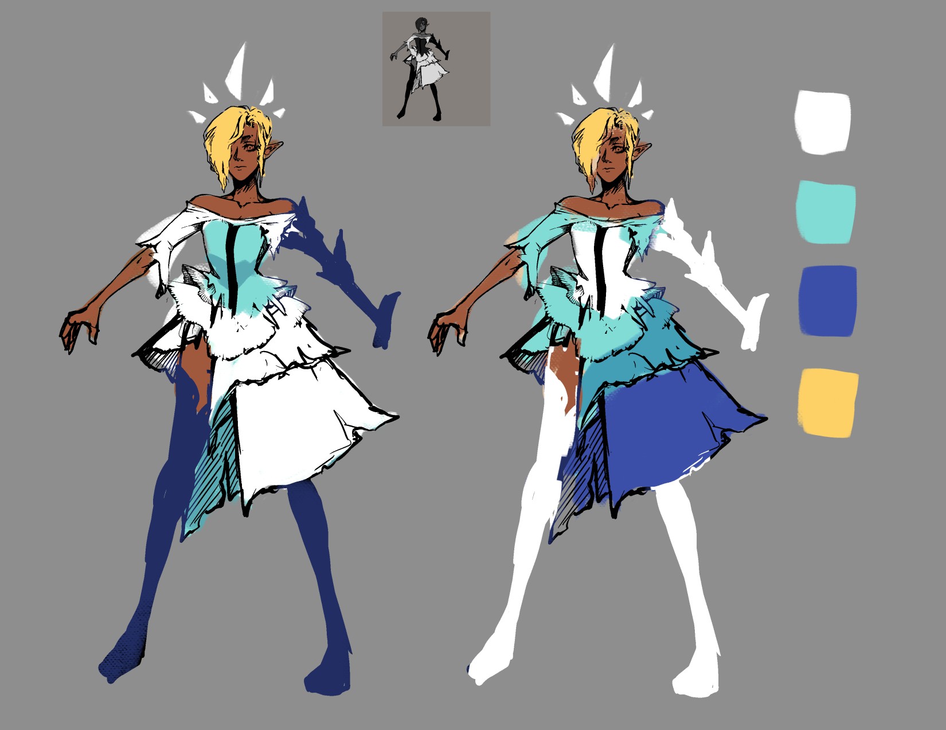
- Echoes will be using a mixture of 3D and 2D assets
  - The game world will be made using 3D proxies in engine to render a 2D tilemap
  - Tilemap and environment textures will be 2D
  - Character and enemy assets will be 3D
- Assets will be primarily hand-drawn, stylized
- Sound design is still WIP pending creation of the audio team

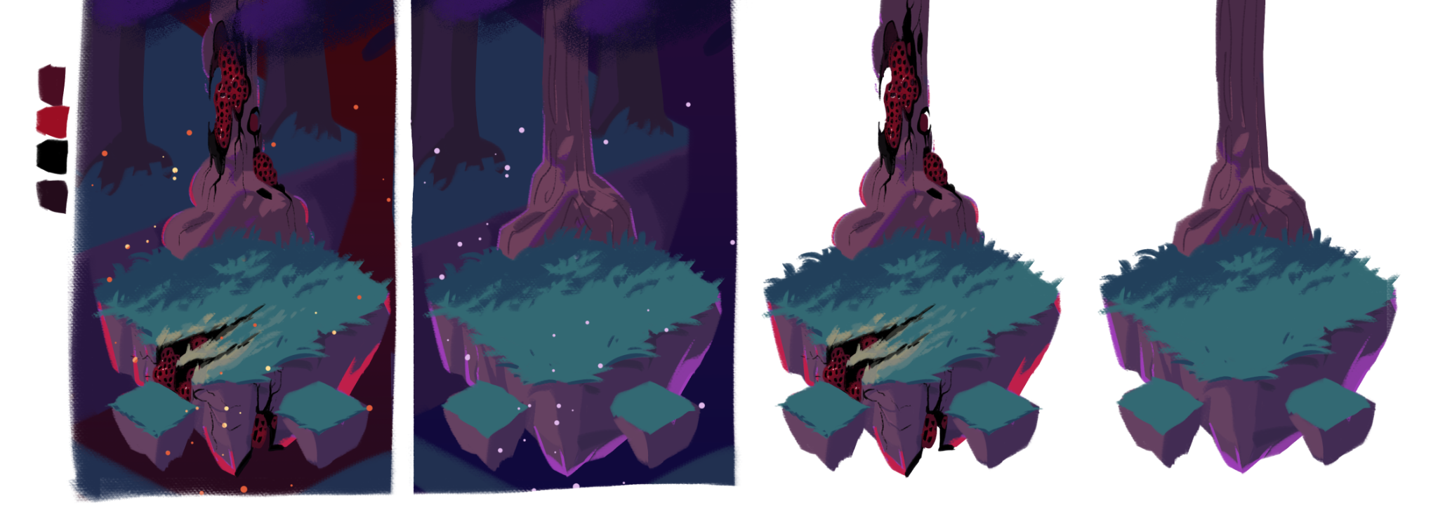

Glossary of terms
- Augment: An item type that gives additional properties to Beira’s existing abilities
- Base item: The basic items that given to players at the start of the tutorial (available by default)
- Beira: The player character, who is an amnesiac fae queen, embarking on a quest to regain her lost memories by exploring her former kingdom.
- Chest: A container found in the faewild that can store a variety of items and other rewards.
- Starting item: Items that can be picked as part of your starting loadout.
- Dash: Beira’s primary form of mobility, which allows her to travel at extreme speeds to target Faerie circle, damaging enemies she passes through on the way.
- Eile: Beira’s kingdom, which controls a large portion of the faewild. After Rot usurped the throne, Eile has since fallen into ruin.
- Enemy: Hostile creatures found across the faewild.
- Faerie circles: A small circle of stones where magical ley lines converge. Beira can dash to these from far away.
- faewild: The realm of the Fae, home to all sorts of mythical creatures.
- favors: The currency of the faewild, used to buy goods at the shop. favors can be collected from fallen enemies and shrine rewards.
- Hazard: Dangerous objects that can be found all over the faewild.
- Health: Beira’s hitpoints, which determines how much damage she can take before dying.
- Hub: A magical sanctuary where Beira has found refuge during her exile. Players respawn here after dying.
- Items: Items are power-ups that make Beira stronger when equipped. They can be found in shrine rewards, bought from shops, and unlocked in the Well of Memories
- Interactable: Objects found across the Faewild that Beira can interact with.
- Loot Pool: The selection of all possible items that can show up in shrines and shops during a run.
- Obstacle: Objects that block Beira’s movement and dash.
- Passive: An item type that gives Beira a static effect. May require specific conditions to be met.
- Region: A distinct area of the Faewild, represented by a level in the dungeon.
- Rot: The antagonist of the game, who stripped Beira of her memories and usurped her throne.
- Run: A segment of gameplay that includes everything after the player enters the Faewild and continues until the player dies or beats the game.
- Shop: A friendly vendor that sells various goods to denizens of the Faewild in exchange for favors.
- Starting loadout: Items you start your run with already equipped. Can be customized before each run.
- Variant: Stronger versions of basic enemies, which present additional challenges during combat.
- Well of Memories: A powerful artifact located in the hub that helps recover lost memories via meditation. Beira can spend tears of epoch here to unlock new items.

